目录

VR PHYSICAL BODY(V2.0.2) 1

1.How to set up 1

2.Use your own model to make a vr physical body 3

3.Adjust your hand posture 4

4.Edit custom hand pose 5

# VR PHYSICAL BODY(V2.0.2)

## 1.How to set up

The URP example template is recommended.

1. Install the **OpenXR** and **XR Interaction Toolkit**

2. Import the resource package

3, You may be prompted to add TextMeshPro, just follow it

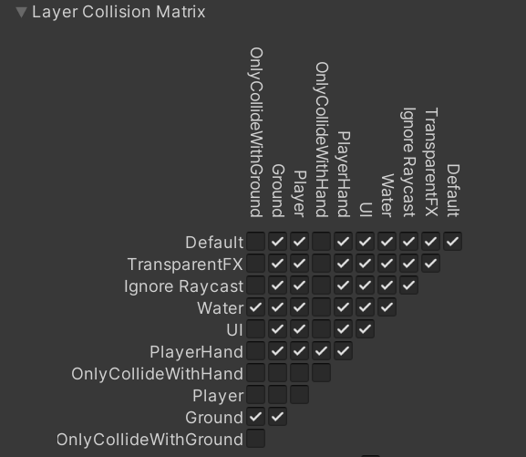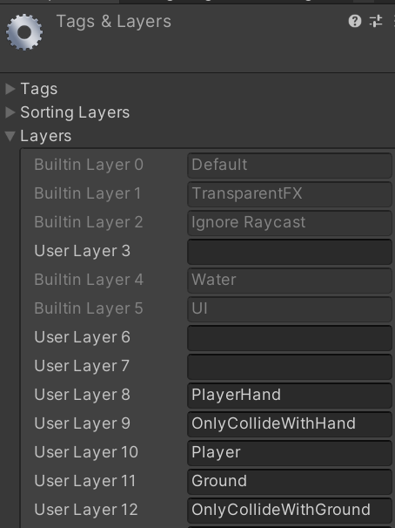4. **Add Layer** and set **collision matrix**, as shown in the figure

5. Run it and add the missing tag according to the error

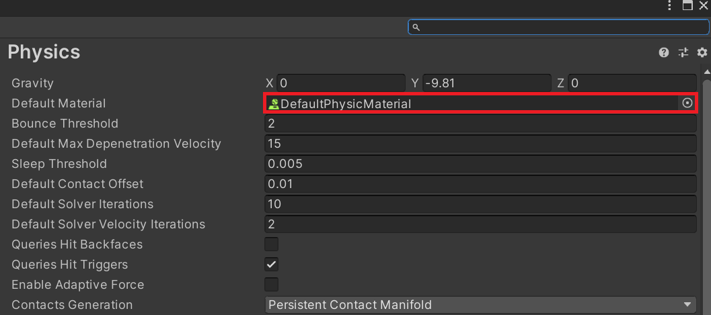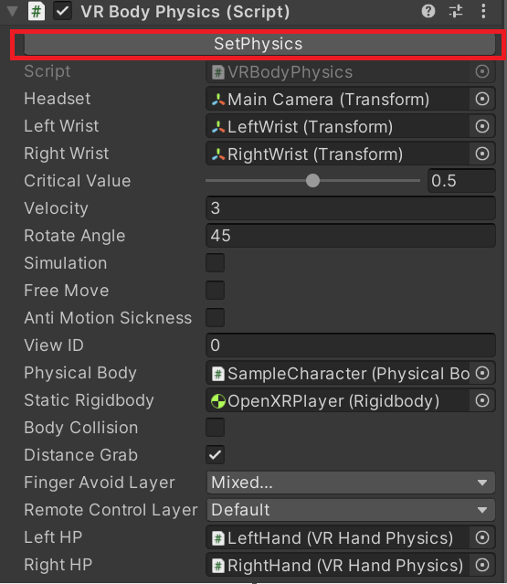6. Click ‘**SetPhysics**’of the VRBodyPhysics script. Then set ‘**DefaultPhysicsMateria**l’ as the default physical material.

7. Add **‘Ground’** layer to all the floors.

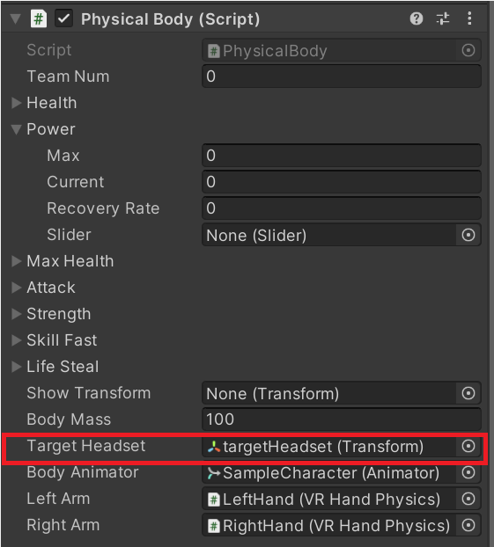8. After generating VR physical body, if your camera is blocked by the model head at runtime, you can **increase the near clipping planes** of the camera, **reduce the localScale** of the model head, or **adjust the local position of TargetHeadset**

## 2.Use your own model to make a vr physical body

1. 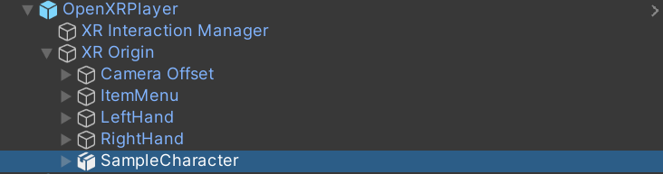Remove **‘Sample Character’** under **‘OpenXRPlayer’**, and drag your own model into your scene.
2. Add a **‘Physical Body’** script to your model. Colliders are automatically created when the **‘Physical Body’** script is added.
3. Check the body and hand colliders for fine adjustments.

## 3.Adjust your hand posture

1. 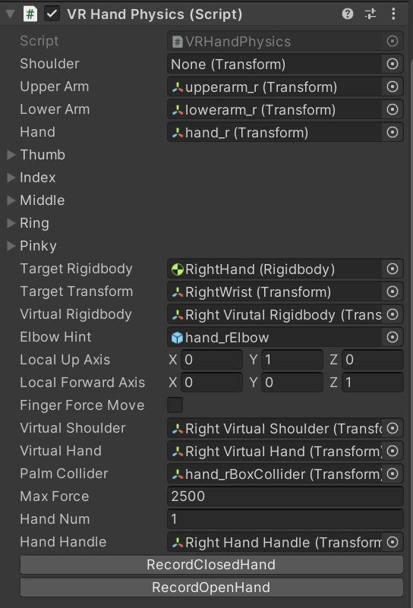Navigate to the **‘VR Hand Physics’** script
2. Right-click on **‘VRHandPhysics’** and execute the corresponding function to show the recorded poses. If you are not satisfied with the default **open/closed** posture, you can adjust fingers to **open/closed** posture in editor and click the corresponding button to record.
3. As for the auxiliary grasping script **‘Handle’**, its coordinate axes are partially aligned with the gameobject **‘HandHandle**, according to the selected alignment mode. Finger poses are automatically calculated without editing.

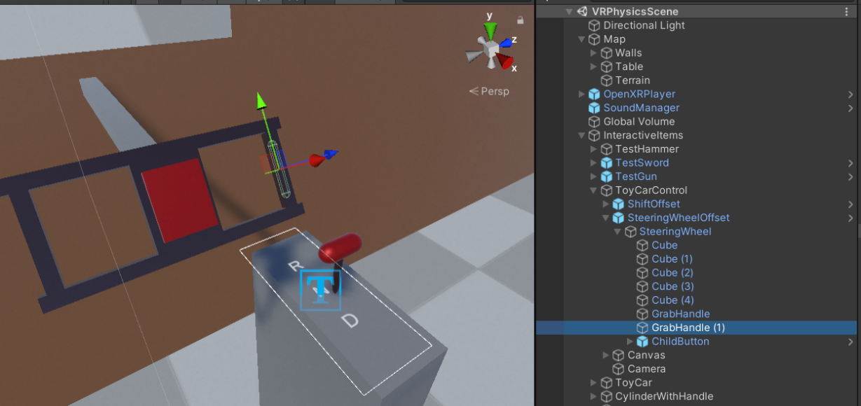

## 4.Edit custom hand pose

1. Click **‘Align Transform**’. Your hands will move to the handle.

2. Move your hands and fingers to achieve an ideal holding position. Just move your **wrist, thumb and index** finger. The rotation of other fingers is calculated automatically at runtime.

3. If you only need a static holding position, record **open and closed** pose for the same pose.

4. Remember to **revert transform** when you are finished recording

You can watch the instructional video on the asset store page to get a step-by-step guide. Pay attention to the version, some may be outdated. If there is a difference, refer to the latest version of the instructions.

Welcome to [my discord](https://discord.gg/3FYnhMCxQW).

If you have any questions, please contact my email: [vrnightcrawler@gmail.com](mailto:vrnightcrawler@gmail.com)